 | GENERIC TOWAGE ASSESSMENT
For vessels falling outside the Minimum Towage Requirements

Section A – Vessel Details
Name of Vessel: |  | Cargo Type:
Agent: |  | DWT:
Length Overall(m): |  | Beam (m):
Max Draft (m): |  | Air Draft (m):

Section B – Manoeuvring & Towing Equipment
Propeller(s) type |  |  | Transverse effect*:
Dead Slow Ahead Speed (kts) |  |  | Min Steering Speed (kts)
Rudder(s) type & position:
Thrusters (no./kW/type): | Bow |  |  | Stern
SWL of Bitts** (specify tonnes or kN):
Other relevant info:
*Transverse effect LH (left handed) RH (right handed), or Inward or Outward for twin screw vessels. **1 tonne force = 9.9 kN

Section C – Planned Movement
Channel: |  | Berth: |  | Side to Quay:

Available tugs within Belfast Harbour – Master may indicate preference

David Ferran and Sons
Type of Tug | Conventional | ☐
Length (m) | 15.43 | ☐
Breadth (m) | 5.45 | ☐
Bollard Pull (t) | 14.8 | ☐

Belfast Towage Ltd – 3 available
Type of Tug | ASD | 1☐  2☐  3☐
Length (m) | 24.39 | 1☐  2☐  3☐
Breadth (m) | 9.15 | 1☐  2☐  3☐
Bollard Pull (t) | 45 or 50 | 1☐  2☐  3☐

Section D – Towage Required (completed by pilot) * Preliminary method proposed for planning purposes — final method to be agreed during the Master Pilot / Tug Master Exchange. Deselect as necessary.
Inward Tugs - No. & Pull | >10T | ☒ | >40T | ☒ ☒ ☒
Inward planned method of towage * | On the line | ☒ | Push-Pull | ☒ |  | Hipped up |  |  | ☒ | Indirect |  | ☒
Other method please state:
Comments e.g. tug type, disposition, etc. | If no tugs required state “None” here:
Is outward towage to be separately assessed by inward pilot/Master? YES/NO
If NO, complete below tug requirements:
Outward Tugs - No. & Pull | >10T | ☒ | >40T | ☒ ☒ ☒
Outward planned method of towage * | On the line | ☒ | Push-Pull | ☒ | Hipped up |  |  |  | ☒ | Indirect |  | ☒
Other method please state:
Comments e.g. tug type, disposition, etc. | If no tugs required state “None” here: |  |  |  |  |  | Assessed at/following inward transit (YES/NO)
Assessment valid for average wind speeds up to (kts): |  |  |  |  |  |  |  | Max gusts (kts)
Pilot completing Towage Assessment:
Confirming Harbour Master:
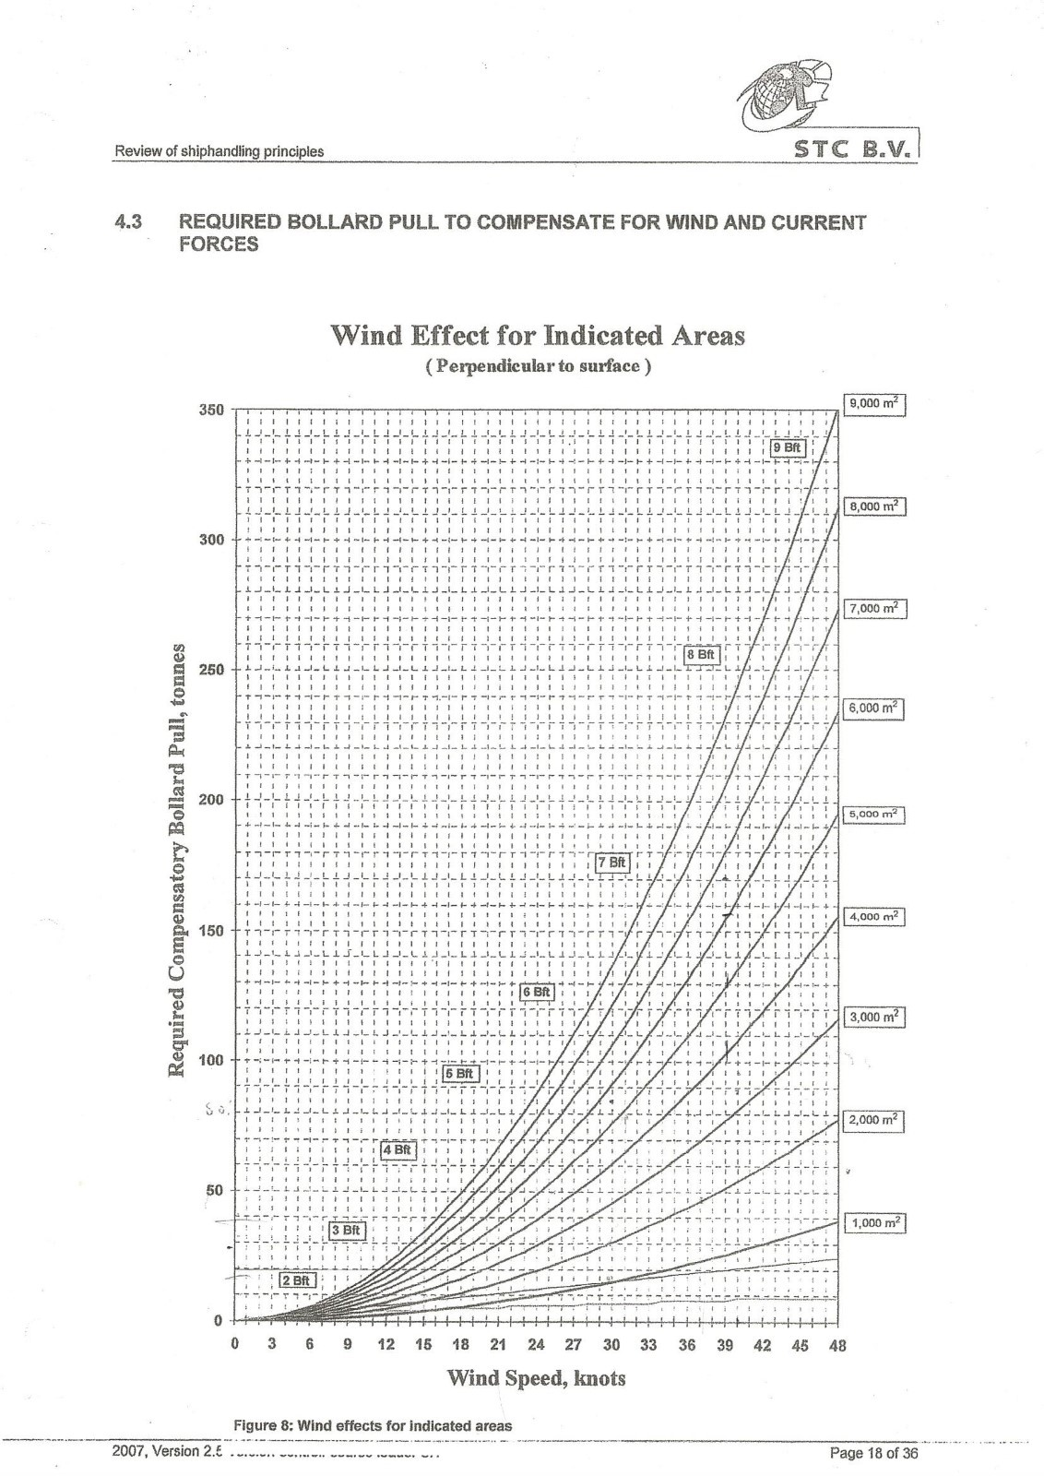
ig.1 - STC B.V. Wind loading curve

